**FACULTY OF INFORMATION COMPUTING SCIENCES**

**DEPARTMENT OF COMPUTER SCIENCE**

**Title:**

**Organ Donation System with integration of AI and Blockchain**

**Submitted by:**

|  |  |  |
| --- | --- | --- |
| **Iqra Iqbal Khan** | **---** | **M-20/F-BSCS-29** |
| **Sameed Saeed Khan** | **---** | **M-20/F-BSCS-26** |
| **Muhammad Aqib** | **---** | **M-20/F-BSCS-51** |

**Supervised by:**

**Muhammad Saleem**

**FACULTY OF INFORMATION COMPUTING SCIENCES**

**DEPARTMENT OF COMPUTER SCIENCE**

**CERTIFICATE**

This document which testifies that the group members have finished their teamwork of this FYP thesis entitled **“Organ Donation System with integration of AI and Blockchain**” has been signed by **Mr. Muhammad Saleem** who is the supervisor of the group members. The job is authentic, sound, and to us it is completely correspondent to the requirements for FYP.

|  |  |  |
| --- | --- | --- |
| **Iqra Iqbal Khan** | **---** | **M-20/F-BSCS-29** |
| **Sameed Saeed Khan** | **---** | **M-20/F-BSCS-26** |
| **Muhammad Aqib** | **---** | **M-20/F-BSCS-51** |

**Supervisor:**

______________________________________________________

**Muhammad Saleem**

Lecturer

**FYP Coordinator**                           **Chairperson**

**Dr. Fida Hussain Khoso                 Dr. Fida Hussain Khoso**

**Associate Professor  Associate Professor**

**FACULTY OF INFORMATION COMPUTING SCIENCES**

**DEPARTMENT OF COMPUTER SCIENCE**

**DEDICATION**

Our enthusiastic vision of this project is sincerely dedicated to our well-respected teachers, who continue to inspire us as well as teach us valuable lessons concerning the world, knowledge, and understanding. Without their unshakeable belief in us and constant boosting moral, we couldn’t have imagined the courage to see the project from the very beginning till the end.

Hence, all the energy and time that we have spent on the overall elaboration and the implementation of this project are dedicated to the families who have got us to here. We'd like to thank our mothers who have showed them their greatest love and never-ending support in whatever challenges we seize.

Particularly significant for us are the teachers and families that have been with us throughout our lives and the entire maturation process that we are proud of. Thank you.

**FACULTY OF INFORMATION COMPUTING SCIENCES**

**DEPARTMENT OF COMPUTER SCIENCE**

**ACKNOWLEDGEMENT**

The inexplicable happiness and satisfaction that I get when my project is coming to an end and the whole period I have worked on it is the same happiness I would not want to forget as it is seconded by my appreciation of the efforts of all people whose cooperation I have throughout the process. Memorably in these great people, our project supervisor, Mr. Muhammad Saleem, has been special in his tremendous assistance, constant advice, and insight reports which have guided and formed us to this level of completion.

Mr. Muhammad Saleem's profound expertise and wise diction has made us reach our benchmark in our resolve to excellence, thus being sure that our efforts will encounter a resounding success. Through his guidance, we have learned how to be better at tackling complexities of this project, and slowly but surely we build skills and virtue.

On this imperative note, both we and Mr. Muhammad Saleem would like to express our heartiest and genuine acknowledgment of the vital roles they have done as team members. Whether it be their analysis, their creativity or their diligence, there's no doubt their involvement has made a difference. We could not thank them enough for their contribution in this project.

Table Of Contents

Table Of Figures …………………………………………………………………………………………………7

List Of Abbreviations ……………………………………………………………………………………………8

1. Introdcution 10

1.1 Introduction 10

1.2 Background 10

1.2.1. Organ Donation 10

1.2.2. Blockchain-Based Organ Donation 11

1.2.3. Ai Integration In Organ Donation 12

1.3 Project Vision: 13

1.4 Problem Statement: 14

1.5 Objectives: 14

1.6 Project Scope: 15

1.7 Key Challenges: 15

1.8 Limitations: 16

2. Requirement Analysis 18

2.1 Requirement Analysis 18

2.2 Literature Review 18

2.2.1 Organ Donation Management: 18

2.2.2 Organ Donation & Transplantation In Pakistan 19

2.2.3 Non-Blockchain Based Solutions: 21

2.2.4 Blockchain Based Solutions: 21

2.2.5 Organ Donation & Transplant: Traditional Evaluation Process 23

2.2.6 Technological Convergence: Ai-Powered Systems 24

2.2.6.1. Ai Integration In Kidney Donation And Transplantation 26

2.2.6.2. Ai Integration In Liver Donation An Transplantation 30

2.2.6.3. Ai Integration In Lung Donation And Transplantation: 33

2.2.6.4. Multi-Organ Disease Detection Using Ml Approach: 35

2.3 Stakeholders List 35

2.4 Requirement Elicitation 36

2.5 Functional Requirements 36

2.6 Non-Functional Requirements 37

2.7 Software Development Life Cycle Model 38

3. System Design 40

3.1 System Design 40

3.1.1 Architecture Design: 40

3.1.2 User Interface Design: 40

3.1.3 Security Design: 41

3.1.4 Ai Model Integration: 41

3.1.5 Notification Mechanism Design: 41

3.2 Use Case Diagram 42

3.3 Data Flow Diagram 43

3.4 Sequence Diagram 43

3.5 Class Diagram 44

3.6 Gantt Chart 45

4. References 46

**TABLE OF FIGURES**

Figure 2.1: Software Development Life Cycle Model 37

Figure 3.1 Use Case Diagram 40

Figure 3.2 Data Flow Diagram 41

Figure 3.3 Sequence Diagram 41

Figure 3.4 Class Diagram 42

Figure 3.5 Gantt chart Project Timeline 43

**LIST OF ABBREVIATIONS**

|  |  |
| --- | --- |
| AI | Artificial Intelligence |
| ML | Machine Learning |
| DApp | Decentralized Application |
| SIUT | Sindh Institute Of Urology And Transplantation |
| PHOTA | Punjab Human Organs Transplantation Authority |
| POTA | Pakistan Organ Transplantation Authority |
| NCHS | National Centre For Health Statistics |
| KDPI | Kidney Donor Profile Index |
| EPTS | Estimated Post-Transplant Survival |
| ECC | Elliptic Curve Cryptography |
| ECG | Electrocardiogram |
| MRCP | Magnetic Resonance Cholangio Pancreatography |
| NADRA | National Database And Registration Authority Of Pakistan |
| ANN | Artificial Neural Network |
| SVM | Support Vector Machine |
| DCNN | Deep Convolutional Neural Network |
| MADM | Multi-Attribute Decision Making |
| HLA | Human Leukocyte Antigen |
| XGB | Extreme Gradient Boosting |
| CNN | Convolutional Neural Network |
| LR | Logistic Regression |
| A-NRP | Abdominal Normothermic Regional Perfusion |
| CRNN | Convolutional Recurrent Neural Networks |
| PECA | Pakistan Electronic Crimes Act |
| KNN | K-Nearest Neighbor |

# INTRODCUTION

## INTRODUCTION

Utilizing Blockchain and Artificial Intelligence (AI) for organ donation management is concerning privacy, safety, and efficiency and transparency issues. Blockchain technology can be used for privacy of donor records and EMR due to its decentralization, immutability, and transparency characteristics. Furthermore, it opens doors for designing algorithms and smart contracts for inspection, pairing of donors and recipients, as well as registering. Moreover, the AI techniques like ML and regression models are utilized for predicting the best performed donors and recipients, and for assessing the level of the understanding and worries around organ donation among the users. These advanced technologies help to lower malpractice rates and improve patient satisfaction by creating a system that is democratic, effective, and reliable in handling organ donation and transplantation.

## BACKGROUND

The background of this project involves a number of issues among which there are the concept itself of Organ Donation and the currently applied techniques. Moreover, the integration that the use of Blockchain and AI technologies in this process has brought also needs to be examined. The whole course has been detailed enough for us to go further to look at Organ Donation with integration of Blockchain and AI.

### ORGAN DONATION

Transplantation of an organ means beginning of a process wherein the organ is taken out from the donor and placed inside the recipient body who has got an organ that is not working properly besides being transplanted to impart a new life inside the body. The donor can be living or lifeless persons. Living donors donate organs that are capable of only giving one such as kidneys, liver segments or lung portions wherever deceased donors can offer in a plurality such as heart, lungs, liver, pancreas, or kidneys Generous organ donation hold a key place in a way of supporting or improving the weak conditions of patients living with life threatening illnesses.

Thousands years ago, organ donation was practiced during the time of Rigveda. It was performed by Ashwini Kumaras who also performed both homo and hetero-transplantation procedures in ancient times **[1]**.The very first successful organ donation occurred in 1954 with a kidney transplant between two identical twin brothers in Boston, United States of America by Dr. Joseph Murray **[2]** followed by the first successful liver transplant in Denver, United States of America by Dr. Thomas Starzl in 1963. Since that time, there has been a consistent rise in the annual number of transplants **[2]**.

Organ donation process itself is a source of big amount of data, and applying a software system will be an appropriate choice to manage this data with making its safe storage and access to medical staff or other legitimate persons. Thus, the system can increase the degree of the data and this can prompt the consumers to take the decisions fully knowing what organ they will get. Not just that, it allows for meticulous tracking and reporting of all the execution levels so as to rest assured of compliance with the regulatory set-ups and foster transparency and accountability. Firstly, the use of the software may maximize organ donation fairness as well as justice because it only relies on objective criteria like medical needs but not the subjective factors like the wealth of the persons.

The process of organ donation and transplantation entails a number of steps, crucial amongst which is the following **[1]**:

* Diagnosis of the brain death: For someone to qualify for organ donation, it is necessary to pronounce them as brain dead first. However, this is a needless step in every donation case.
* Assessing medical suitability: Once brain death is confirmed, the individual’s health records and condition at that moment will be checked to see whether they may be a suitable organ donor.
* Matching the recipients: Once considered an ideal organ donor, the organs of the respective individual will be assigned to recipients whom they require transplantations. This procedure entails matching the type of blood as well as tissue of the donor against those of the recipient in order to guarantee survival of new organs.
* Organ retrieval and Transplant: As there is a match found, organs are taken off through surgery from a donor and put inside a new host.

### BLOCKCHAIN-BASED ORGAN DONATION

Blockchain technology, created by an enigmatic figure known as Satoshi Nakamoto in 2008, revolutionized the concept of decentralized databases **[3]**. Originally implemented for Bitcoin, Blockchain  enabled secure, peer-to-peer transactions without the need for validation from traditional third-party institutions. It functions as a distributed ledger, recording transactions in interconnected blocks that are immutable and shared across a network. Each node in the network holds a copy of this ledger, ensuring transparency and security.

Blockchain have different forms, categorized by the accessibility of their distributed ledgers. Public Blockchain allow any user to access and participate in confirming transactions anonymously. In contrast, private Blockchain are controlled by a single entity, giving them the authority to manage the network and alter the ledger's content. Permissioned Blockchain strike a balance, with organizations overseeing membership and ledger allocation while granting individuals permission to confirm transactions **[3]**.

Lately, Blockchain  technology has caught the public eye across various fields, as it presents a decentralized, trusted ledger without the need for an intermediary or a central body. Most of its activities tend to involve information architecture, which pertains to database structure, distribution mechanisms, level of accessibility as well as various types of consent. Blockchain  technology can enhance organ donation systems by providing a clear audit trail, reducing fraud risk, and increasing trust. It can also track organs and associated data efficiently, ensuring proper matching with recipients. Furthermore, Blockchain  enhances privacy and security of sensitive data. Overall, it can greatly improve transparency, security, and efficiency, potentially saving lives **[4]**. Blockchain  is a secure and transparent ledger that records transactions in a decentralized and immutable manner. While initially popular in finance for Cryptocurrencies and smart contracts, its use has expanded to other sectors like healthcare. Here, it offers secure, efficient, and transparent data storage and sharing capabilities.

Computers’ AI mimicking humans keeps on learning new data as opposed to humans for a long time that reason is behind AI. A number of innovative ideas that involve technologies for the benefit of society in general, rely on AI. It is being increasingly used in the healthcare sector to enhance patient outcomes, reduce costs, improve healthcare administration, and address public health issues **[5]**. AI in healthcare involves the use of advanced analytics to make predictions, guide decision-making, and take appropriate actions. It has the potential to revolutionize the industry by analyzing large amounts of data to identify patterns that can lead to better diagnosis, treatment, and patient outcomes.

### AI INTEGRATION IN ORGAN DONATION

Integrating AI in organ donation and allocation has the potential to address various challenges in the field. AI can be defined as the capacity of a machine or computer system to simulate and carry out human-like processes, including logics, learning, and problem-solving, which are traditionally unachievable for machines. AI is ML algorithms application and other automated technologies that enable machines to perform some high-level processes on their own while being completely or semiautonomous. AI is marked by the degree of capability or autonomy for example. It can either be powerless or narrow in its aspect and scope, or it can as well be of superior quality. As the autonomous aspect of the system, it can be reactive, deliberative, cognitive or fully autonomous. The development of AI affects the improvement of many processes, and tasks that currently appear sophisticated are simply going to be performed faster and with high quality **[6]**. AI is not merely a replication of human capabilities but rather a technology deeply integrated into the human life world, shaping our interactions with the world we live in **[7]**. AI systems are capable of constructing algorithms from data, performing specific operations on images, and making predictions in the healthcare sector **[8]**.

AI can assist in optimizing the kidney allocation process by identifying high-risk kidneys that are difficult to place, allowing for accelerated placement and improved kidney quality **[9]**. Additionally, AI models such as the MCNN-HELM can be used to predict suitable organ donors for recipients, minimizing waiting time and improving patient outcomes **[10]**. In the field of transplant pathology, AI-powered computational pathology can enhance diagnostic accuracy and guide organ allocation decisions, leading to improved donor pool and reduced errors **[11]**. Furthermore, AI can play a crucial role in improving the quality and accuracy of pre-transplantation biopsy reports, ensuring consistent and reliable results for surgical decision-making **[12]**. Overall, integrating AI in organ donation and allocation has the potential to enhance efficiency, improve patient outcomes, and address the challenges faced in the field.

The field of Machine Learning (ML) can be considered as a subfield of AI, in which a core idea is that an algorithm analyzes massive amounts of data from the raw sources and generalizes to perform predictions or classifications of unseen datasets. ML, therefore, could be applied as either supervised learning, where the models are provided with outputs, so as to match the observation's characters to a known outcome; unsupervised learning, thus the data being unlabeled and unknown patterns discovered through the ‘automatic’ induction process; or reinforcement learning, which refers to the training of ML models in an interactive environment by making a series of decisions through trial and error using ongoing feedback **[13]**. ML can differentiate between complex and heterogeneous datasets, which can be a source of big, intricate, and precise outcomes and predictive models. ML tools have been used in many of the disciplines in medicine where data including its complex and interrelated aspects exists and thus generation of predictive models with the potential to improve healthcare delivery.

## PROJECT VISION:

Our project strives to radically change how organ donations are managed using Blockchain  and AI, which are the most advanced technologies available nowadays. We foresee a system that facilitates transparency, security, and efficiency, which make a huge leap in the organ donation procedure and allow to equitable allocate organs to those people who badly need them. Via Blockchain  incorporation, we intends to create a community-drawn platform in which the organ donation process is fully transparent and can be trusted by all parties. Also, we will be using AI algorithms for finding the perfect match between donors and recipients, thus optimizing the organ allocation process and increasing the success rate of the post-transplant procedures. This initiative will have far-reaching effects that are likely to bring transformational changes to the organ donation sector with many lives being saved and the atmosphere being improved.

## PROBLEM STATEMENT:

In Pakistani organ donation system the major problem of the roots deep in traditions and societies are found. It’s often the case that patients use their living donors as a source of organs due to the significant constraints on cadaveric organ donations such as religiosity, the low socio-economic status and diminished demographics. While this technique is highlighted by many drawbacks like information concealment, organ allocation failure and insufficient volunteers for donating. Hence they are burdened with long waiting periods and functioning becomes difficult to do for them, thus reducing chances of their survival.

Nowadays, despite the unquestionable necessity of donor organ submission programs, three major obstacles severely influence the workability and the pros and cons of these programs. Transparency deficit often is the case, and nobody determines how the organs are allocated thus, creating confusion and ambiguity as to how donating and receiving transactions are being conducted. Another critical factor is the dependence on conventional matching methods with the sluggish and in some cases inefficient speed that is the problem that aborts organ allocation. Other than that, the lack of trust and ignorance of the general population is a barrier system because of the problems in transparency and operational flaw, which is caused by the actual practices. Resolving these challenges is a key pre-requisite to enhancing the organ donation process, which is a complex interconnected system by nature, which should also be fair and equitable with everyone onboard.

## OBJECTIVES:

The goals for the project can be summarized into three items. The first key goal is to develop a Decentralized Application (DApp) for organ donation management that reduce dependence on single authorities and healthcare centers by increasing the accessibility, security, and scalability of the service. In addition, the project relies on transparency to improve the organ donation process, employing Blockchain technology to establish an immutable and friendly record of all occurring and accomplished activities connected to donation. Additionally, this project should connect the AI capability with predictive analytics to get the system to analyze data and predict trends in organ donation and transplantation, thus ensuring that the organ donation system works both efficiently and effectively.

## PROJECT SCOPE:

The main objective of this project is the introduction of a new system for allocating organs based on the Blockchain  and AI technology. This system is supposed to be safe, quick and reflect the success of the recipients of the vital organs. Donators and receipt will register on an easy navigate website that will give each unique key to store the personal data privately. Hospitals shall give disabled people medical assessments. The donor shall successfully undergo business screening after which their data shall be hashed and made available on a secure Blockchain  ledger with their respective key, validated by the hospital. The other document specifics will be done to the donors when it is the recipient's turn. The AI-based matching engine will anonymously fetch the data from the Blockchain  by filtering out the possible matching pairs by using the medical criteria. There will be both patients and healthcare professionals who are left anonymously feeling whom they have potential to match with and so they can proceed with the life-saving donation process.

## KEY CHALLENGES:

The process of designing a Blockchain  and AI-based Organ Donation System for Pakistan is fraught with major obstacles, which need to be analyzed and innovative measures to be taken in order to be successful in this venture. However, with the integration of these technologies in the existing country infrastructure and regulatory environment there is a complexity in the implementation process. Blockchain and AI integration in Pakistan's healthcare system could be difficult because the country might not have a well-developed technology which could lead to these changes in the system. Also to note, the legislative framework in Pakistan that relates to healthcare and technology might appear to be complex; therefore, strict compliance procedures are essential for the system to be in order and meet the law relating to the issue.

Besides, privacy, the question of data safety is another complicated matter in Pakistan. Such as affecting the health sector and also other types of the sector, the country has experienced number of challenges from data breaches and Cybersecurity issues. It is imperative to put in place tangible security measures as well as ensuring adherence to data protection regulations so that the information in use is not compromised. Besides that, the restoration of trust and support of the new system implementation in a country with so many cultural and social variants can be a great obstacle. Being transparent about the advantages and security measures of the system would be a critical step in weeding out the challenge of varying levels of understanding of cyber security.

Moreover, an incomplete dataset to train the AI using is another obstacle to bear with. Creating a dependable AI model for organ inscription and predictive analysis in Pakistan can turn out to be difficult owing to diverse reasons among them limited availability of justifiable and substantial data. It is vital to try to collect and synthesize such information from different provider settings, organ donor programs, and others. Synergy among stakeholders and compliance to privacy regulations are the common denominator to this challenge and the production of an AI-Powered Organ Donation System in Pakistan.

In regards to the mentioned problems as well, the implementation of Blockchain technology in the Organ Donation System deals with several major issues. Another great barrier is the ignorance of the Blockchain  technology and the shortage of information about this technology among the stakeholders such as the donors, recipients and medical professionals, who may not be familiar with this type of technology. Educating these groups of people on the pros and cons of Blockchain  is a vital action to take, to make them understand and accept system innovations. The scalability of Blockchain  technology is another problematic area, due to the increase of an organ donation exchange volume. It will be imperative for the network to be scalable and able to deliver its services without losing quality.

Similarly, working on the interoperability between the Blockchain and existing systems and technologies within the Pakistani healthcare infrastructure will also be of paramount importance. The system should be able to combine with other healthcare systems with no hassle in order to avoid obstacles during the transfer of information. Finally, looking into the various regulatory and lawful issues of Blockchain  application including data privacy and ownership rights is very important to make sure that laws and regulations are always followed by the area. As such, solving these issues will require an enormous endeavor from all contributors including the agencies of the government, health professionals, technology experts, and the public. Cooperation and conversation are the main tools that will allow us to go through these challenges and efficiently deploy the system of Blockchain as Organ Donor System in Pakistan.

## LIMITATIONS:

Various limitations are involved in building the technological platform of the organ donation system which is based on the Blockchain andAI technology. Major obstacle is the absence of the dataset suitable for gaining data for a ML model training. Quality of data, consistency and size of carried data are fundamental characteristics ensuring the performance and generalizability of AI algorithms. Beyond this, the fact that Ethereum ends up being the baseline Blockchain technology presents some limitations as well. Ethereum represents indisputably expensive choice in application costs which can be potentially problematic in context of large-scale applications like organ donation systems. Furthermore, the lack of scaling ability and slow transaction speeds of the Ethereum platform impede the handling of the high volume of data within donation process.

Also, the current Blockchain  systems that are concentrated on Ethereum mainly give us the fixed peer-to-peer networks, and cannot be flexible due to the nature of the chosen protocols. This being the case the turnover in our system can be difficult due to the lack of the personalization and the optimization. As the Ethereum Virtual Machine based crypto coin, Ether could have insufficiency for organ donation systems because of the scalability problems and the transaction speed problems it has. Furthermore, Ethereum public and permissionless characteristics can bring about the issues of donor and recipient information obviousness and confidentiality. While inherent to the nature of the Blockchain, the limited storage capacity poses a challenge when needing to store large data sets. Thus, it is not feasible to keep all data on chain which would never happen.

# REQUIREMENT ANALYSIS

## Requirement Analysis

The Blockchain  and AI-facilitated organ donation system requirements analysis is aimed at clarifying and delimiting the stakeholders’ needs and expectations related to organ donation process. This analyzes is critical to presenting the functional and non-functional requirements of the proposed system as well as the technical and operational imperative for its development.

## Literature Review

The Blockchain  technology and ML capabilities are now the talking point of organ donation through the proposal of new means of addressing long acknowledged problems. There are many studies done on how these technologies including 3D bioprinting may be revolutionary in the organ donation field. For this purpose, we consider both the block-chain and the non-block based solutions as well as the traditional and the AI which have been suggested so far as the solutions for the problems within organ donation system.

### Organ Donation Management:

The very first successful organ donation occurred in 1954 with a kidney transplant between two identical twin brothers in Boston, United States of America by Dr. Joseph Murray followed by the first successful liver transplant in Denver, United States of America by Dr. Thomas Starzl in 1963. Since that time, there has been a consistent rise in the annual number of transplants **[14]**. Nevertheless, there remains a shortage of organ donors compared to the demand for organ donations. In fact, an average of twenty people die each day while waiting for an organ transplant, with a new patient added to the waiting list every ten minutes **[15]**. It is crucial to note that access to the organ donation waiting list is a fundamental prerequisite for organ allocation. Factors such as geography and socioeconomic status can impact a patient's referral for transplantation. Therefore, the process of allocating organs from the waiting list should be equitable and not discriminate against any particular group of patients **[15]**.

As discussed in full detail by Diana Jawad Hawashin in their thesis works referenced at **[16]**, Organ donation occurs through two main methods: deceased donation and living donation. The process typically begins with an examination of the donor by the hospital's transplant team. If the donor is deceased, a brain death test is conducted to confirm the cessation of brain function. For living donors, a thorough examination is done to ensure their suitability for donation and to check for any pre-existing conditions that may affect the donation process. All medical records are then submitted to the procurement organizer, who evaluates the donor's condition and registers them in the medical system if they are deemed eligible. If the donor consents to donate anonymously, their information is forwarded to the organ transplantation organizer, who matches the donors with patients on the waiting list. A ranked list is generated, and transplantation surgeons assess the suitability of the organs for their respective patients based on various factors. Once a match is found, the donated organ is removed by the donor's surgeon and transported to the recipient's hospital, where the transplant surgeon receives it. If the donation is from a living donor to a known recipient, the data is sent directly to the transplant surgeon to initiate the surgery.

The primary issue with this method is that the integrity of the data is fully dependent on how well transplant centers manage to protect their systems and identify possible risks to donors and recipients. Residents' confidence in the centers' to be able to keep wait-list data secure from hackers and dishonest employees is paramount for the credibility of the data **[17]**. Transparency is another major issue in organ transplantation. For the World Health Organization (WHO), 10% of transplanted organs may have been illegally bought through organ trafficking, although the exact number is not known. Transparency among partners can cause donors and medical professionals to commit unethical practices **[18]**. Some hospitals abuse patients' organ need by offering organ to those paying more who are not in need of organ by stepping on patients with the highest priority on the waiting list. On the other hand, today's transplant systems are sometimes inefficient, which is unacceptable in life-threatening situations. The major problem in these systems is that they usually don’t have the latest security requirements, which results in an increase in data breaches and compromises the users’ privacy and system integrity. While the majority of current systems use regular databases, a large number of hospitals, health ministries, and medical institutions still don’t have a standard-communication system in place **[19]**.

### ORGAN DONATION & TRANSPLANTATION IN PAKISTAN

Organ donation in Pakistan faces several challenges and barriers. The country heavily relies on living donor liver transplantation due to the lack of deceased organ donation. Many potential living donors are deemed ineligible for various reasons, including medical issues and withdrawal of consent **[20]**. Additionally, Organ trafficking poses a significant challenge in Pakistan, driven by factors like poverty, exploitation of minors, and a shortage of viable organs for transplantation. Poverty forces individuals to sell their organs for financial gain, while vulnerable minors are exploited into the illegal trade. This demand for organs fuels the illegal organ trade, exacerbated by the lack of proper legislation and enforcement. The imperfection of these policies is a cause for concern, for it slows down the process leading to some individuals resorting to the unorthodox means of getting organ donation. The transplant of human organ and tissue Act 2010 apart from regulating organ removal, storage, and transplantation, also lack specific policy measures and implementation strategies that can effectively fight organ trafficking **[21]**. Organs are in the highest demand more than they are available. This leads to people having to wait for a long time for their donation leave their lives to be cut short.

It was back in 1980s with the first successful kidney transplants, when such systems of more organized donation of organs stirred up organizing process. With the yellow-faced gremlins running rampant throughout the town, you can do nothing but second guess yourself. So what happens in 1990 when conversations sparked among doctors and government officials about the requirements of clear rules? This meant the approval of the Transplantation of Human Organs and Tissues Ordinance in the early 1990's and 2000's, which is the legal basis that regulates donation and transplantation of organs. A watershed moment was realized in 2007 when, for the first time, the Sindh Institute of Urology and Transplantation (SIUT) spearheaded created public awareness on donation of organs from deceased donors. That is 2010 which was significant for being a time when the Human Organs and Tissues Transplantation Act was enacted, substituting the old rules and improving the process with more control. PHOTA, the Punjab Human Organs Transplantation Authority, was formed as an authority in 2012, while the same task was performed by POTA, the Pakistan Organ Transplantation Authority, which was established in 2016 but there was a national effort in managing organ donation and transplantation. The government had by 2018 launched awareness campaigns such as that aimed at low awareness or cultural barrier topics, mostly focusing on organ donation as a means of growth and progress into healthcare in Pakistan.

There is a situation in Pakistan where several patients lose their lives to terminal organ failure and look for organ transplant for their survival. The exact numbers are not available; however, it is said, that each year more than 50000 people die for end-stage organ failure without getting a transplant, among them approximately 15000–18000 from kidney failure, and 10000 from liver failure, according to the National Centre for Health Statistics (NCHS). These two kinds problems are the great causes Nevertheless, all these efforts were done to increase the knowledge of population in Pakistan about organ donation among 60% only. In Pakistan, the lack of existing deceased organ donation schemes and the people’s reluctance to participate in dead organ donations are the reasons behind the demand for a living organ donation. Therefore, the patients still depend on living donors **[21]**.

The study in **[22]** focused on the opinions of 342 individuals, and noticeably 82.18% had never heard of Pakistan's Organ Donation Registry, 58.09% agreed with organ donation and 23.68% wanted to join the registry in the future. Religious beliefs, as well as no knowledge about the laws governing the national organ donor registry, are the main obstacles of joining the national organ donor registry. The promotion of an organ donation culture and sensitization is vital in dealing with the insufficiency of organ donors and improving the medical donor organ transplantation in Pakistan.

### Non-Blockchain Based Solutions:

In non-Blockchain-based methodologies, a range of techniques and tools are employed to develop solutions that improve organ donation, transplantation management, and the matching process.

With reference to the researchers' work in **[19]**, they created a complex information management system made up of different agents that regulate the donor hospital, regulator, and recipient hospitals in the context of an organ transplant. This virtual platform eliminates and streamlines the pre-transplantation processes therefore boosting the efficiency of the process as a whole. In addition, it enables the storing of the donor candidates' data and provides the participants with the communication platform, which reinforces the teamwork and assures the appropriateness of the whole organ transplantation procedure. By conducting a numerical assessment of this platform, the results clearly showed that it would save between three to five hours; this indicates its great potential to transform the organ donation and transplantation process. The source is an online resource that aims to educate individuals about organ donation and transplantation from Cleveland Clinic.

The TransNet system used in **[23]** allows the barcode scanning for barcode labeling, packaging, and tracking of organs and other biological items for transplantation. The core of this mechanism would consist of a developed app and a handheld barcode printer that correlate with DonorNet. Operating room coordinators access the existing system and print any labels they need and scan all organs to be transported during organ recovery.

The authors in **[19]** proposed in their paper “Mechanisms for online organ matching”, the MIN mechanism for matching deceased organs to donors online, aiming to enhance efficiency and fairness in patient selection in Australia's current organ donation system. This mechanism prioritizes assigning organs to patients based on minimizing Kidney Donor Profile Index-Estimated Post-Transplant Survival |KDPI-EPTS|, with tie-breakers based on waiting list time and random selection if necessary. The KDPI assesses organ quality, while the EPTS measures recipient quality of life post-transplant. Testing demonstrated that the MIN mechanism surpasses the current system being evaluated by the Organ and Tissue Authority in Australia.

### Blockchain Based Solutions:

In Blockchain-based methodologies, various approaches and tools are utilized to create solutions that enhance organ donation and the matching process. In **[23]**, the authors suggested a decentralized app for organ donation using Blockchain. Patients would register their details, like medical ID, organ and blood type, and state, using a web app. The system would work on a first-in, first-out (FIFO) approach, except for critical cases. It promised improved security, transparency, and speed. However, adjustments would be needed for different regions based on their rules and requirements. In other research works referenced as **[19]** a kidney donation system called "Kidner" was introduced, based on Blockchain  technology. It includes a kidney-pair donation module instead of the standard kidney waiting list. For instance, if someone wants to donate their kidney to a family member but they are not a match, Kidner matches the donor's kidney with another patient in a similar situation.

In a study referenced as **[19]**, researchers developed a web-based application that utilizes a First-In-First-Out (FIFO) approach to select an organ donor for each patient requiring a transplant. This methodology ensures a fair and systematic process for matching donors with recipients, with priority given to emergency cases. Additionally, the authors of **[23]** proposed an innovative organ donation and transplantation application based on Blockchain  technology. This application facilitates the registration of both donors and recipients by hospitals, enabling the system to match them efficiently. By leveraging Blockchain, this system enhances the security, transparency, and traceability of organ donation processes, potentially revolutionizing the field.

Nevertheless, a Blockchain  solution was manifested pertinent to organ donation in **[24]**. Agreement by the donor to donate organs starts with he or she signing the smart contract for organ donation and then the patient making a transplant request. These documents are authenticated by the figure in the registered healthcare institute and the hash function is employed to create a verified mismatching pair and then the documents are broadcasted over the network. After that, the network looks for similarity and passes it to another health care professional for approval. The hash is generated once the match is confirmed, and then the concerned healthcare professional approves it, and the next step is for the hash to be created. Right after the hash is generated, the pair which is proven matched is added to the Blockchain. Ultimately, doctors and other healthcare providers receive the exact information package they need on the logistics of the surgery.

In another paper **[49],** the system is suggested to achieve the paradigm shift in organ donation through the employment of Blockchain technology to ensure security, transparency and efficiency. It digitalizes and improves the existing process, and helps to process a large amount of data quickly, which provides transparency and cost-effectiveness in a secure manner. User privacy and security are achieved by our Blockchain-based access control system architecture deployed using Elliptic Curve Cryptography (ECC). E-Government integration allows the usage of patient and disease data with Blockchain and smart contracts. The system shows better metric performance, presenting an outlined indicative of high accuracy, precision, recall, and F-measure values. The development of such system needs to be done with a given consideration to a system development, testing, regulatory compliance, user education, and improvements that are in line with the Blockchain and organ donation management technology.

Furthermore, the Blockchain developers in **[18]** introduced a DApp that helped tackle some challenges in the existing organ transplantation system by addressing the lack of communication between donors, recipients and the existence of illegal organ trade and high transplantation costs. The DApp utilizes smart contracts and a centralized wallet architecture to ensure efficiency, security, and transparency in the organ transplantation process.

### ORGAN DONATION & TRANSPLANT: TRADITIONAL EVALUATION PROCESS

Between June 2022 and March 2023, Pakistan Kidney and Liver Institute & Research center (PKLI RC) evaluated 364 potential living liver donors for liver transplant recipients **[20]**. The evaluation process involved three steps:

**Step 1: Initial Assessment**

Prospective donors had a complete blood examination that consisted of the blood grouping, liver functioning and screen for infectious diseases such as hemophilia B, hepatitis C and HIV. Thoracic radiological assessments X-rays, liver ultrasounds and electrocardiograms (ECG) were done as well. I also asked for an advice to a transplant surgeon.

**Step 2: Further Radiological Evaluation**

A detailed CT scan with a triphasic protocol was performed to obtain precise imaging of the liver and surrounding structures.

**Step 3: Additional Radiological and Laboratory Investigations**

Additional evaluations which included MRCP and 2-D echocardiogram, liver and cardiac functions, were performed. Thrombotic risk is examined by specific tests, along with biochemical and immunological tests being performed for assessment of immunological status.

This comprehensive process of evaluation was directed at evaluation of the appropriate donors and diminishing of potential risks connected with liver transplantation. While it is true that the organ allocation process currently works without the need for AI, it is important to understand that medical diagnosis and assessment of the donor's suitability to ensure the best prospects for transplant recipients are made using existing medical-related protocols rather than AI techniques.

Screening and selection of donors as one of procedures in which possible donors must be first, second, or third relatives of the recipient and within age (18 to 50 years). This integration of two countries through their legal systems was made possible with the cooperation of National Database and Registration Authority of Pakistan (NADRA). The recovery team had an independent physician assess and inform the potential donor about the nature of surgery being done and the donor can take back consent of liver donation up to the time of presenting the consent to them. As required, it was approved by the ethical committee of the hospital and the PHOTA. Furthermore, the tests were conducted by a technician after ensuring that donors were compatible for ABO blood type and that they were healthy **[20]**.

### TECHNOLOGICAL CONVERGENCE: AI-POWERED SYSTEMS

AI (AI) is a factor in many medical procedures regarding organ allocation as well as some of the post-transplant processes. AI models especially ML and DL are being applied to generate clinical decision support systems for the physicians who deal with transplantations **[25]**. These algorithms are used in evaluation procedures like listing for transplantation, the work of organ allocation algorithms, deciding for transferring a certain organ to a person, and the prediction of morbidity or mortality to a person on a waiting list **[11]**. AI is applying here from image processing, donor and recipient matching, pathology, real-time to immunosuppression, transplant oncology and predictive analysis. The utilization of AI-based computation pathology together with digital pathology helps to enhance the diagnostic precision and thus safeguard the quality and safety of the transplantation **[12]**. The AI in organ transplantation has the ability to make best use of organs, give good results of transplantation and less number of transplantation.

ML technologies hence demonstrate impressively lucky offer for organ allocation and transplantation purposes, thereby elevating patient outcomes. Exploiting ML algorithms would allow the clinicians to solve donor-recipient compatibility issue and a standard score which is the basic requirement for a transplantation success.

In order to achieve the goals of ML based systems, the data preprocessing process being of crucial importance will prepare consistent and superior databases. This facilitates the fairness and robustness of the algorithms as a complement to upskilling and reskilling expert human decision making processes.

Different ML approaches have been implemented in the field of organ tranplantation with the reported effectiveness of the algorithms managing the large data sets and improving the process of donor- recipient matching. Techniques based on deep learning, including Artificial Neural Network (ANN) ensemble methods, have been used for regression and hence for estimating graft survival probability in kidney transplantation. Support Vector Machine (SVM) techniques are employed for optimization of the quality of match between donor and recipient as that is the best predictor of graft survival.

The implementation of AI-based systems in organ donation waitlist allocation significantly impacts the timely receipt of organs for transplantation. These systems utilize ML algorithms to enhance the quality and speed of pathology reports, ensuring consistent and accurate assessments of donor organs. By digitizing slides and training AI algorithms, these systems can provide precise organ donation-focused pathology reports promptly, reducing delays in organ offer acceptance and minimizing ischemic time. Additionally, AI aids in identifying suitable recipients based on medical parameters and critical requirements, streamlining the organ allocation process and facilitating efficient organ transplantation. Overall, AI-driven technologies optimize organ procurement and allocation, ultimately improving the efficiency and effectiveness of organ transplantation procedures.

The paper **[26]** proposes the development of an intelligent organ transplant system using k-anonymity and a rank search algorithm to efficiently match organs with suitable recipients and can significantly reduce the time taken to search for organs based on medical parameters, critical requirements, and location. By leveraging mapping algorithms, this system aims to streamline organ donation efforts globally, ultimately assisting more patients in need to increase their availability, making organ transplantation more efficient.

The implementation of the k-anonymity allows for organ transplant data to be protected from any kind of breach, so as to ensure the security and privacy of the data, and a rank search algorithm that identifies the most suitable organ recipient for an organ donor. The implementation of these modalities greatly speeds up the process and makes organs available at a higher rate and is an important factor in the upward trend in transplantation efficacy.

On the whole, this paper’s approach has a positive promise in reducing waiting lists and ensures that patients are timely transplanted following pharmaceutical criteria, therefore improving patient prognosis and addressing the health crisis of organ donation.

In liver transplant medicine, ML models like ANN are often applied as a complement to increase the probability of graft survival and reduce the risk of graft loss as well. Besides, methods of decision tree, random forest, and ridge regression also have been evaluated for predicting graft survival after kidney transplant, which once again proved the usefulness of these methods in predicting post-transplantation outcomes.

Moreover, in another paper **[50**] that is given as a reference the results highlight the effectiveness of machine learning (ML) models in predicting donor selection with a high recall and area under the curve (AUC). Besides, the achievements of heart and lung transplants go hand in hand with the expectations of being more successful in the multi-organ transplants. The various algorithms used for the classification can be categorized into the three groups which are K-Nearest Neighbors, Logistic Regression, Random Forest, Support Vector Machine, XGBoost, and Artificial Neural Networks (ANN). The algorithms were improved by nested stratified 5-fold cross-validation and grid search for hyperparameter tuning. Also, imputation, standardization, and oversampling techniques were used during the model development period, and dummy variables were created by one-hot encoding and labeling through the numeric transformation of ordinal variables. The points made in the study point out the unclearness of the donor selection process and the results of the organ outcomes from OPOs. The fact that ML models provide high predictive accuracy for donor selection and multi-organ transplant outcomes has been proved. Besides, the administrative challenges and the specificity of organs are the main things that make the organ allocation difficult. To sum up, XGBoost is a revolutionary technology that could be an excellent tool for improving transparency in the process of organ allocation in OPOs.

Particularly, Deep Convolutional Neural Network (DCNN) has given the most accurate results of prediction of the patients who will survive liver transplantation which once again points to its significance for the examination. Moreover, ML algorithms like Cox, SVM, and Gradient Boosting have been effectively utilized in liver transplantation for various purposes, further emphasizing the widespread application of ML in transplantation medicine **[27].**

#### AI integration in kidney donation and transplantation

Our kidneys play a crucial role in keeping us healthy by filtering waste from our blood and producing important hormones and urine. When kidney function drops below a certain level, known as end-stage renal disease, it can lead to serious health problems and even premature death.

For those facing kidney failure, there are two main treatment options: kidney transplantation and dialysis. While kidney transplantation offers better survival rates compared to dialysis, there's still a significant risk of losing the transplanted kidney over time.

Since kidneys are in limited supply, it's vital to match donors with recipients carefully to improve transplant outcomes. This matching process considers various factors that affect the survival of the transplanted kidney. Although many studies have explored these factors, the interactions between them are complex, leaving much to be understood.

As presented in the article **[30]** the used algorithm which is based on the evaluation of the criteria by points principle is seen to have an effect on the ability for the Latvian Transplant Centre (LTC) to allocate kidneys optimally among the recipients. It can also be seen to support clinical decision makers in finding the most suitable donor-recipient match. The algorithm is based on multi-attribute decision making (MADM) methodology, which involves dividing the problem into smaller pieces, then analyzing each part, and combining the parts to give a conclusion and a more coherent decision. MADM is selected as the method providing the basis for the algorithm developed based in medical experts' outputs on donor-recipient matching and sees a kidney allocation problem as an undirected graph, with each node representing a compatible or incompatible donor-recipient combination. It is a very effective method as it helps find a donor very suitable for a specific recipient through optimization of both donor and recipient profiles and priority It resorts to the greedy algorithm approach for its decision making. The algorithm has the prospect of preventing more than 30% of grafts that fall out in their first year from the transplantation, consequently offering better outcomes for the kidney transplant recipients.

Another paper **[28]** introduces a novel model based on representation learning to forecast donor-recipient compatibility in organ transplantation. This model surpasses existing allocation methods, including those executed by human experts. By learning representations that cluster donor features and applying donor-invariant transformations to recipient features, the model addresses matching bias and covariate shift challenges in donor-recipient joint distributions. Experimental findings, drawn from both semi-synthetic and real-world datasets, underscore the model's effectiveness in predicting transplant outcomes and enhancing transplantation success rates.

* The paper uses two datasets for experiments which are the one that PDF24 is used for conversion and the other one is the one converted by PDF24. The first input dataset includes 6898 twins who had two donors and two recipients, while the recipients were characterized by 55 features and the donors were represented by 28 features.
* The second dataset is the lung transplant data set from UNOS, which comprises two sub-datasets: the first one with 60,400 survived heart recipients and another experiment on 29,210 lungs burnout survivors.Each sub-dataset has 37 donor-recipient features.

Semi-synthesized data with synthetic datasets provide one of the ways to model the best method of clustering the potential donors and establish policies allocation based on currently available observations. Besides, the model offers the capability of meeting the distribution gaps while also generalizing well to donors' and recipients' marginal distributions, it positions the model as a promising method candidate for transplantation allocation strategies.

The study **[29]** employed a Cox regression-investigative tool to find which--patient or–donor sets caused graft loss or patient death. It noted that size matching was the criterion of choice for predicting patient and graft survival after kidney transplant operations. The conjunction of such factors, comprising the class of variables with relations independent and D-R, were important to foresee an exact diagnosis of allograft loss. Which itself implies that it is necessary to take into account all the risk factors involved, providing immunologic and demographical ones, especially when it comes to getting more accurate prediction of grafting loss and the enhancement of an outcome of patients.

ML algorithms have a chance to predict in a post-kidney transplant setting that graft will fail with at more accuracy than traditional statistical techniques can. These algorithms consider take into account recipient variables like age, gender, comorbidity together with HLA match as vital predictors among others. Performance assessment metrics like accuracy, precision, recall, and AUC-ROC show how well perceptual models perform. The present systematic review demonstrates how the ML algorithms can multiply the fidelity of the prediction process that is fueled with the objective of advancing the eventual performance of the patients that have gone through kidney transplant[30].

However, the prediction models of the transplant outcomes have certain constraints as they tend to score between 0.6 and 0.7 into receiver operating characteristic scale mean the models require refinement to achieve reliable outcome for the transplant. The report selected a two-way approach that is a combination of traditional statistics and contemporary ML (ML) platforms to arrive at the future long-term survival trends of kidney transplant recipients. The Kaplan-Meier estimator, Logistic Regression (LR) and Cox proportional hazards models are among the conventional statistical techniques which are first applied.

In parallel, ML algorithms like ANN, Extreme Gradient Boosting (XGB), K-Nearest Neighbor (KNN), Decision Trees (DT), and LR were integrated into the analysis for more comprehensive predictions.To refine the predictive models, feature selection techniques such as Least Absolute Shrinkage and Selection Operator LR (LASSO), Random Forests (RF), Decision Trees (DT), and Chi2 were employed. A meticulous process led to the training and testing of 35 distinct models, ultimately culminating in the selection of the most effective model for predicting post-kidney transplant survival **[31]**.

The research also encompassed a meta-analysis of 31 studies, all of which delved into utilizing ML models for forecasting graft survival rates post-transplantation. Key data extracted from these studies included details such as publication year, country of origin, feature selection methodology, ML algorithms employed, validation techniques, demographics of the study population, and types of input variables, dataset sizes, outcomes, and follow-up periods. A diverse range of input variables, spanning pre-transplant, intraoperative, and post-transplant factors, were considered across these studies. Feature selection engineering (FSE) was specifically deployed in 19 studies to pinpoint the most pertinent clinical variables for inclusion in the predictive models.

Across the included studies, a total of 29 distinct ML methods were employed, showcasing the breadth of approaches utilized, including ANN, recurrent neural networks (RNN), decision trees (DT), support vector machines (SVM), Bayesian belief networks (BBN), and gradient boost (GB).

ML gives hope in refining techniques for better estimation of a transplanted kidney’s ability to function by gathering crucial data with complex patterns. In a comprehensive study that examined 27 different models, these ML algorithms were found to have an 81% predictive rating related to graft survival, with a positive diagnostic ratio. When compared to traditional regression models, these ML algorithms slightly outperformed, with an accuracy rate of 74% predicting graft longevity over three years **[32]**.

The synthesis of traditional statistical methodologies with advanced ML techniques underscores the profound impact of AI in enhancing the accuracy and efficiency of predicting survival rates and other risks in post-kidney transplant patients.

Another study **[33]** explores the use of ML in predicting kidney graft failure post-transplantation. By developing advanced prediction models and analyzing donor and recipient characteristics, researchers aim to optimize kidney allocation and improve long-term health outcomes for recipients. Innovative techniques such as deep learning-based auto-encoders and non-overlapping patient stratification were employed to enhance prediction accuracy. ML algorithms like Support Vector Machine and AdaBoost were utilized, with SVM showing superior performance for short-term predictions and AdaBoost for subsequent cohorts. The study underscores the potential of ML to revolutionize post-transplant care and improve outcomes for kidney recipients.

The study **[34]** aims to discuss in detail the role of ML in using available data for decision making at organ procurement phase and improving the general transplant success. An instance of the current ML model is after, random forest algorithm, what showed strong performance that was predicted to provide additional 2,148 transplant due to the conventional way of the Cox regression and the kidney donor risk index. Both of these methods produced a precision of 10%. Furthermore, the rforest model has a higher prediction accuracy than risk index that can be validated with Kaplan-Meier analysis, which indicates that rforest model can predict transplants that are more successful and longer-lasting. To begin with, supplementing the segment selection with recipient variables notably increased the explanation power of the random forest model and, therefore, bettered the model’s plication accuracy, especially for longer survival graft results. Extra identification of gaps in the performance of models allowed us to conclude that RFDR (Random Forest with Donor and Recipient variables) model showed better results than RFD (Random Forest with Donor variables only) and KDRI models especially with regards to prolonged graft outcome. Hence, incorporating sophisticated ML models like Random Forest into clinical decision making has a tremendous potential to enhance the number of donating kidneys.

#### AI integration in liver donation an transplantation

AI integration in liver donation and transplantation processes holds promise for improving patient care and outcomes. It aids in patient stratification, lesion analysis, and improving management. It automates tasks, enhances imaging criteria, and optimizes organ allocation for better outcomes **[40]**.It can also enhance donor-recipient matching in liver matching by handling numerous variables efficiently. It optimizes management for hepatocellular carcinoma patients, aiding in survival **[35]**.

AI-ECG aids in pre-operative risk assessment for cardiac complications in liver transplant candidates, showing potential for implementation in liver donation and transplant evaluations for improved risk prediction**[36]**.Implementing AI in liver donation and transplant can enhance pathology reports, reduce organ wait times, and improve outcomes by accurately assessing organ viability based on digitized biopsies **[12]**.

 The paper **[37]** delves into the application of ML algorithms (MLAs) such as ANN and decision trees (DT) in liver allocation (LA) and predicting waiting list mortality. MLAs are compared to conventional statistical methods, assessing their capacity to discern patterns and complex interactions among variables.

Optimal classification trees (OCTs), a specific type of decision tree, are highlighted for their ability to account for future splits and capture underlying dataset characteristics. Additionally, a systematic review evaluates AI's role in predicting post-transplant survival, encompassing MLA and conventional statistical method performance assessments. Specific ML techniques, including random forest classifiers (RF) and ANN, are mentioned in a study gauging MLA effectiveness in predicting graft failure.

 AI, particularly MLAs like ANN and DT, demonstrates potential in refining liver allocation and predicting waiting list mortality, surpassing conventional statistical methods. AI's integration in LA holds promise for optimizing life-years gained through equitable, need-based organ allocation, yet its accuracy and clinical applicability hinge on robust dataset availability, regional validation, and expert evaluation. Nevertheless, the ultimate decision-making responsibility in LA should remain with humans, guided by ethical and just principles.

In the paper **[38]**, the study emphasizes the crucial role of granular data collection and ML (ML) modeling in optimizing organ allocation, particularly for recipients of non-directed living liver donor (ND-LLD) grafts. By developing ML models, clinicians can identify potential recipients with the best predicted transplant outcomes while considering complex donor-recipient interactions. These models facilitate clinical decision-making and aid in optimizing outcomes for ND-LLD hepatic graft recipients, offering evidence-based guidance in allocation decisions. Moreover, the utility-based model developed in the study provides a less subjective approach to allocating hepatic allografts from ND-LLD, with the flexibility to tailor to each liver transplant program's characteristics.

Incorporating data from the liver dataset which obtained from the OPTN, study conducted the retrospective analysis from 2000 to 2019 that included records of the recipients who have undergone the transplant of the liver from the living liver donors grafts. The database comprised of both direct and non-directed living liver donation instances, with attributes such as the recipient and donor ages, sex, race and genu-transplant values like the grafts and cold ischaemia times (CIT) being recorded.

Similarly, random forest survival models were used to estimate the survival rate for recipients undergoing LDLT from different graft donors for each session, with predictors including the body surface area ratio of the donor and recipient, pathologic diagnosis, and medical site of operation factored in. C-index was used to use diagnostic accuracy of the model in forecasting the 10-year graft survival, and for further comparisons between actual and 10-year graft survival. Such comprehensive and data-driven approaches involving ML algorithms and real-world data, offer invaluable information, which helps in improving the allocation strategies for recipients of N-D LDL in hepatic transplants.

In liver transplantation literature **[39]**, machine-learning algorithms, particularly ANNs, and random forest classifiers have arisen as the key instruments for forecasting results, more so in the complex scenario of donor-recipient matching. ANNs have shown amazing ability to recognize patterns and reach high accuracies, for example, 95% in a 3-month graft survival. In such a scenario, the use of ML methods, in particular random forest algorithms, may promote confidence in using marginal organs which could further improve post-transplantation results. On the other hand, these algorithms perform excellently in the managing of wide range of variables from structured to unstructured; and also create relationships among clinically significant risk factors. Using ANNs and random forest classifiers by researchers can discover hidden associations between these factors and consequently, predictions for liver transplantation outcomes approach perfection. It underlines why machine-learning algorithms could prove effective to achieve best donor-recipient matches and thereby improve patient outcomes after liver transplantation.

According to the paper **[40]**, MLAs contribute significantly in predicting the results and outcomes of treatment both before and after liver transplantation, in other words, going a path that leads to early detection and better prognosis. Methods incorporating the KNN, the random forest, the support vector machine (SVM), the LR, the ANN, and the convolutional neural network (CNN) are proved to be efficient in numerous early identification applications that remain relatively successful in the avoidance of severe liver diseases thereby promoting long life expectancy. Moreover, ensemble methods like random forest, boosting by gradients, and boosting by XG help the model do a better job in predictions. Using the vast amplitude of this data through bar codes, automation, and data systems collection to enhance disease prediction becomes one of these systems skills. This prediction might be accurate in the capabilities of ML classification, deep learning, and ensemble techniques combination, which then inspire and implement more effective clinical interventions.

The utilization of ML (ML) algorithms in donor-recipient (D-R) matching for liver transplantation faces challenges highlighted in recent research **[41]**. LR demonstrated superior performance over ML techniques in predicting long-term outcomes, emphasizing the importance of data quality improvement in large databases like UNOS for future investigations. ML methods faced limitations attributed to database subjectivity and accuracy deficiencies, underscoring the need for enhanced data quality and reformulated survival prediction strategies in liver transplantation.

D-R matching in liver transplantation is a highly multi-level matching issue and there should be a set of rules for weighting the donor and recipient variables based on their vital importance for the best outcome. Though liver transplant-donors are not adequate, they are insufficient for transplant-demand. However, there are critical issues in the current allocation methods. The investigation of the United Network for Organ Sharing database was conducted which 39,189 D-R pairs with 28 variables might be used as donor and recipient in different diseases.

Comparison between LR, NB, MLP, RF, GB, and SVM (which are classical statistical methods and Standard ML techniques) revealed LR being better across various end-points such as points at 3 months, 1 year, 2 years and 5 years. Although ML algorithms are very sophisticated, they did not boost liver transplant procedures outcomes perhaps because of the big hindrances of collected data.

According to the paper **[42]**, the development of a deep learning model offers a promising avenue for enhancing decision-making in liver transplantation, particularly in donor-recipient (D-R) matching and outcome prediction. This model exhibits high accuracy in predicting survival after liver transplantation, serving as a reliable tool for medical decision-making. Its transparency and interpretability render it valuable for clinical use, potentially optimizing organ utility in transplantation.

This model has the unique capacity to predict the time interval from transplantation for multiple time points after the transplant. This feature distinguishes this model from previous ones by offering a dynamic approach to the prediction of outcome. The data, made up of information on both recipients and donors of liver transplants between 2004 and 2019, consisting of diseases characteristics, biochemical values, and laboratory tests, is used to develop and train the model.

The analysis has several major parts: demographic information on the recipient, diagnosis and MELD score, laboratory values, demographic data of the donor, donor’s cause of death, donor risk index. Donor information such as preservation time, type of donation, distance transported and quality of graft was equally taken into account.

The model with the deep learning operation showed impressive accuracy rates: the F1 score was 0.899 and the AUC score was 0.940—both of these numbers suggest a high predictability rate. The outcome metrics spanning survival duration frames were found to have high accuracy and validation between performance scores, which further corroborates the effectiveness of the model. While evidence gained through randomized clinical trials in a multicenter setting are an imperative step before implementation of the model in clinical practice for consistency and reliability, the model must also have the potential to be generalized across different patient populations and healthcare settings.

#### AI integration in lung donation and transplantation:

AI (AI) is really a key factor in lung donation mechanisms. Studies have shown that AI can be used to detect abnormalities of breathing in stethoscope recordings for determining lung status. Research was done to provide this information. On the other hand, the application of AI technologies to perform quality evaluation of lungs from category III donors, such as DCD cases, is also benefiting from in situ perfusion systems which perfuse to ensure effective assessment of the viability of donated lungs. Additionally, there is a possibility that AI can be used to further the lung transplantation procedure by making A-NRP (abdominal normothermic regional perfusion) techniques to minimize warm ischemic damage on the abdominal organs and maintain the quality of the lungs. These findings reveal, thus, the extraordinary value that AI brings to the execution of lung donation and its outcomes.

Lung transplantation is essential for patients in respiratory failure, but post-transplant mortality and morbidity rates remain high. Donor and candidate selection are critical, demanding unified criteria and predictive methods. The study in paper **[43],** highlights the importance of optimizing lung donation and transplantation processes, maximizing organ use while ensuring fairness in allocation. By addressing organ shortage challenges through enhanced donor selection and expanded criteria evaluation, the developed model offers a promising approach to improve lung transplant outcomes and resource efficiency.

A developed model for donor-recipient matching for lung transplantation significantly increases success rates by taking a closer look at parameters like donor/pre-recipient lung function, donor ventilation, and ischemia time. As a result of retrospective analysis of 404 lung transplant cases, the creation of such ML model has become possible, by the application of different clinical variables and ML approaches. The combination of LR and neural networks was utilized to strengthen the analysis and achieved super performance over classical statistical methods.

The integration of ML algorithms in lung donation and transplantation is exemplified through the utilization of state-of-the-art techniques in breath phenomena detection. The research **[44]** focuses on developing a system for fully interactive lungs auscultation using AI-enabled digital stethoscope technology, which can potentially aid in assessing lung health status for organ donation suitability. By employing convolutional recurrent neural networks (CRNN) and reinforcement learning (RL) frameworks, the system optimizes lung auscultation procedures.

 A large database of auscultation recordings collected from digital stethoscopes in realistic conditions facilitates the training and validation of the system. These recordings, labeled by experienced professionals, enable accurate identification of adventitious sounds across different phases of the breathing cycle.

 The developed system enables fully interactive lung auscultation, reducing the need for unnecessary doctor visits and supporting telemedicine. By leveraging ML algorithms and RL, the system offers objective assessments of lung health status with minimal auscultation locations, potentially aiding in evaluating lung conditions for organ donation suitability.

 The adoption of the RL framework for lung sounds analysis presents a novel approach, providing a more objective tool for breath phenomena detection. This research signifies the promising role of AI-enabled digital stethoscope technology in assessing lung health status and optimizing lung donation and transplantation processes.

#### MULTI-ORGAN DISEASE DETECTION USING ML APPROACH:

Machine-learning algorithms serve a practically invaluable diagnostic purpose by detecting early stages of diseases within the liver, kidneys, and lungs **[48]**. The tissue damage plays a profound role in the assessment of multi-organ failure, especially in pathologies that are time-consuming and require medical expertise for their diagnosis, which emphasizes the need for innovation. Taking advantage of ML Science, e.g., using Random Forest and Decision Tree algorithms, we can see an improvement in the early-stage detection of multi-organ failure prevailing based on the analysis of patient data and pattern recognition. Data in these algorithms are trained on datasets comprising medical records of patients of hepatobiliary diseases, true renal diseases, CHF disease, and diabetes disease that take into consideration age, gender, systolic blood pressure, and glucose levels as inputs.

Through rigorous data preprocessing, feature extraction, and classification methodologies, the system accurately predicts the likelihood of multi-organ failure with high precision and recall. Evaluation metrics such as accuracy, precision, recall, and F1-score attest to the system's effectiveness in predicting disease outcomes. While the developed models demonstrate promising accuracy rates ranging from 78.96% to 90.49%, further validation and comparison with existing methods are essential to assess their novelty and clinical utility. Ultimately, these ML models hold immense potential in assisting healthcare professionals in early diagnosis and treatment, ultimately improving patient outcomes across various diseases affecting vital organs.

## Stakeholders List

In a Blockchain  and AI integrated organ donation platform, every stakeholder has a thoughtful role that affects how to properly conduct and ethically implement the system. Donors, especially the ones with regenerative organs, are key to the system as the system relies on this organs to save lives. The donors, however, are the people who are preparing their organs for transplantation and whose life is determined on the time and criterion of organs appointment. The job of transplantation centers and organ procurement organizations (OPOs) is not only to facilitate the actual transplantation process, but also to make sure that organs are matched well, as well as to find the necessary donors, so that transplantation can be performed safely. Government health departments make sure technical administration of the association falls between legal and ethical boundaries. Developers of Blockchain  and AI are the keys for ensuring the functions of underlying technology that support the system, however, doctors and surgeons are those who take care of the patients in the frontlines. No stakeholder group is more important than another, the families of the patients contribute to the decision making process as they are a part of it. Ethical committees, health insurance firms, research organizations, organ donor bases, law enforcement agencies, as well as the social circle directly or indirectly participate in the flow of organ donation process flow regulation and support.

## Requirement Elicitation

For the creation of our Blockchain  and AI-based organ donation system, the process of requirement elicitation is essential which largely involves the needs and expectations of all the relevant stakeholders. First of all, we determine the main stakeholders who include donors, recipients, hospitals, and medical services. By conducting face-to-face conversations, we explore the aspirations, fears, and concerns they have regarding the implemented system. We ask particular questions to enable drawing conclusions about the requirements for DApp development, security key generation, communication processes and AI models.

To map the functions of the system, use cases are developed that describe the main interaction modules and features. This aspect involves the development of security keys, how data is appended to the Blockchain, and how AI models are built. We develop prototypes and mockups that show these requirements, thus ALL stakeholders have a chance to offer feedback and suggestions for improvements. This repetitive process helps our final requirements to fit project goals and remain relevant for all stakeholders, making the system designed for organ donation to become effective and useful.

## Functional Requirements

The concept of the project is to create a DApp which works as a common place for organ donations. We have designed a DApp on the Polygon testnet Blockchain platform where people can register to be organ donors. Using the Polygon testnet Blockchain allows our application to work on a stable and reliable infrastructure is the generation of keys for use by user, thereby giving them secure access to the portal. The system would develop dynamic communication between users and the hospitals in a cooperative way by which organ donation would be simplified. User data will be submitted to the hospital tests and when the results will be positive, data will be securely added to the Blockchain, this will ensure transparency and data integrity. Also, our project entails AI models such as LR for determining the risk of organ failure, linear regression for assessing post-transplant survival rates and K-Means clustering for grouping donors and recipients who share common attributes. These AI models will improve the matching process, assessing risk factors and contributing overall to the validity of the organ donation system. And this will ultimately stand for the benefit of the patients requiring organ transplants.

To inform our users about the matches of our organ donation system we would adopt the mechanism that makes use of the both push notifications and email alerts. Among our users who would like email notifications, we will also send emails with details of the match. The email will contain information about such matching elements as organ compatibility and further procedures like a transplant.

## Non-Functional Requirements

The nonfunctional requirements for the Blockchain and AI-Based Organ Donation System may include the specific social, cultural, economic, and technical environment in the country. Primarily, the system has to conform to the rules for healthcare data privacy and security that was passed by Pakistan. It also covers, for example, the observance of the provisions of the Pakistan Electronic Crimes Act (PECA) so as to guarantee the safety of the sensitive data on the platform. The system must be developed in order for it to take in account of Pakistan’s diverse and cultural linguistic backbone. This involves developing multilingual services to offer support to users who have English only as their second language that is the primary language for most of the existing systems. To have an inclusive environment, the system should support the users with disabilities as is the requirement of Accessibility Standards for ICT in Pakistan.

Besides, considering the ability of internet connectivity in Pakistan which is not the same nationwide especially in rural areas, the system should be customized in such a way to be efficient in low bandwidth environments. This implies that the network ought to be designed by keeping in mind that the system function well even if there is slow internet connectivity. Moreover, there should be a back-up plan for intermittent internet disruptions, which should aim at preventing data loss. Subsequently, bearing in mind the intermittent electricity blackouts, particularly in rural areas of Pakistan, the system should thus be energy-efficient and run on the low power devices. These specifications help to ensure that the system always is available even during power disruptions, which is crucial to secure the consistent quality of the organ donation process.

In this regard, the guideline should approach security and data privacy as a priority value, as indicated by the flexible eb network configuration. Therefore, through the involvement of the use of intensely encrypted personal data processes accompanied with periodic audits and upgrading practices, some crucial exposed weaknesses can be limited. Similarly it is recommended to follow best standards of data protection at international level due to various other reasons like provision credibility and confidence to the process of organ donation.

## Software Development Life Cycle Model

The software development life cycle model (SDLC) model as shown in fig 2.1 that will be customized for us to create our Blockchain-and-AI-based organ donation system will be the one we will follow for the implementation of our project. The SDLC (Systems Development Life Cycle) model will include the best practices to make the system being developed to have quality, reliability and efficiency.

In the stage of Planning we will delineate the boundaries, set up the goals, and determine the needs of the project. We will make sure to fully explore the requirements of our stakeholders as well as the technical viability of our message to ensure that it will be as effective as possible. On the other hand, we will construct the project plan, set the timeline, and the budget, as well as take a look at the risks and how we could respond to them.

This second phase of the development process is called Analysis where we will outline the collected requirements from the stakeholders and set the system architecture. Through path analysis of the system, we will be able to identify components, modules, and system interactions at the same time. This stage will also identify data structure and models to be employed for AI integration, these will include prediction of organ failure using a LR, survival rate estimation using a linear regression, and K-Means Cluster for grouping donors and recipients based on shared characteristics.

Phase will be focused on design of user interface, database schema and system architecture in the Design Stage. This is to be achieved by making specific technical specifications that includes anchoring the Polygon testnet Blockchain and Firebase database. This phase to be done with prototyping and usability testing for the sake of establishing a design that matches the standards set by stakemakers.

We will compare data during the Implementation Phase and develop coding, testing, and integration of the system components. We will use the latest soft development practices which includes using the version control, code reviewing, and test automation. Additionally, we will incorporate all security protocols to guard confidential information and to make sure that the system is working well.

In the Testing Phase, we will carry preventive maintenance by conducting a comprehensive testing of the system to discover and eliminate any defects or problems. We are a team of software developers who are responsible for unit testing, integration testing, and system testing in order to ensure that the system works the way prescribed by the functional and non-functional requirements. The last phase will consist of this type of testing which should ensure the realization of stakeholder needs.

The test phase comes to an end with the execution phase where the system should be ready to be deployed in a production environment as per the Production Phase. Provided that all infrastructure is installed and the system is in its operational status at the time stakeholders’ behavior is observed, we will be able to validate mixed-methods approach. During this phase, we will give training to the users and documenting of various procedures which will support the users of this system.

Following the successful launch of the system, we will continue to manage and operate the system in the operation/maintenance phase. In this case the system administration requires regular performance check up, installation of updates and bug fixes, and resolving any user feedback or problems that might come along. In this step, it is essential to have the essential measures that ensure that the system will be run in the short run as well as in the long run.

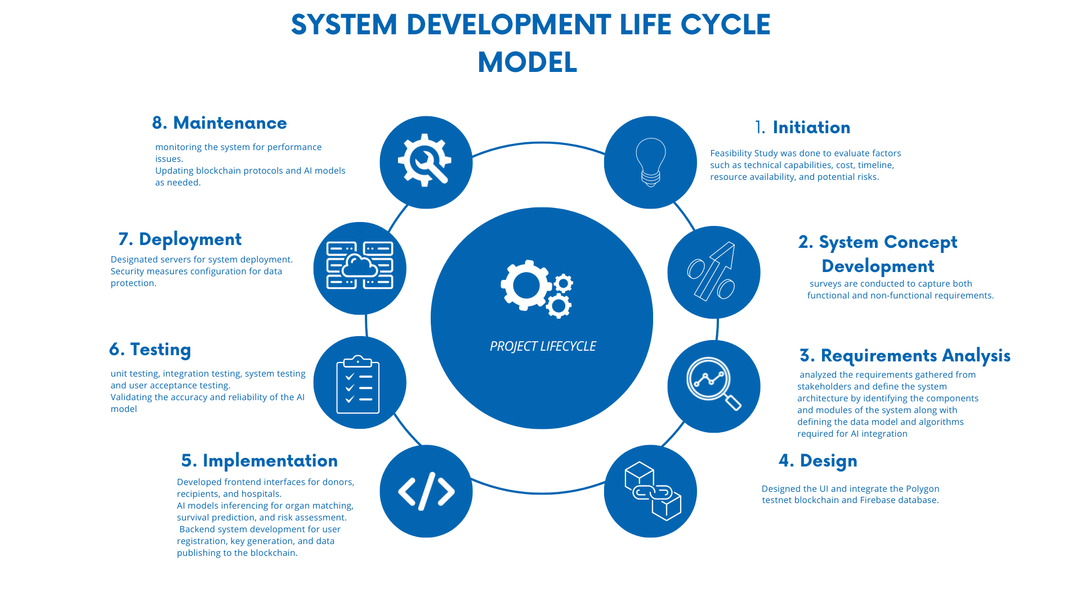

Figure 2.1: Software Development Life Cycle Model

# SYSTEM DESIGN

## System Design

Another critical phase of our project is the system design. The DApp components and architecture of the distributed application that shall be used in the Polygon testnet Blockchain will be the main topics to be addressed during this period. The analysis will be based on the specifications which we described in the previous section, i.e., generation of security keys for end users, communication subsystem for messaging and call functionality, and the employment of AI-assisted models for matching and risk identification.

### Architecture Design:

We will put emphasis on the architecture design and we will type our DApp in the decentralized way via the compatibility of Polygon network with VS Code code editor using Solidity programming language for strong performance and scalability features. Architecture will have the following parts: membership registration block, creating encryption code for security purposes, sending received data to hospitals and storing them in the block chain. Along those lines, we will also design the system to use AI models that are devoted to execution of the job matching and risk evaluation functions.

### User Interface Design:

Regarding its UI design, our DApp would possess a people-oriented and user-friendly UI. Through this mobile application, users will be able to register simply, administer dispensary keys, as well as get informed by hospitals with match alerts. Lastly, the interface will cover the linked information about the number of people who received organs and downloading educational sources on organ donation.

### Security Design:

The aspect of security is also a very important aspect that we look into as part of the system design. In addition, we should use strong encryption, making data transmission genuinely reliable regarding the validity and privacy of personal information. We will also integrate methods of access control to ensure that the sensitive information is only accessible to the right personnel. Furthermore, provided for this means including the segregation of sensitive data as well as keeping records of all operations and transactions in addition to periodic security tests to identify and deal with any security faults.

### AI Model Integration:

The AI models spreading the fabric of our system including LR, linear regression and K-means clustering will represent a part of the system design. These models will be introduced into the system aiming at matching and at assessot (the risk factors component) of the donation. Hence, the structure will bring about the training and and the update algorithms for the model as soon as new data can be fed into the model.

### Notification Mechanism Design:

The made of the system will in addition afford for the situation devoid of when is the match. This system aims to enable the assembly of timely released alert by push notifications and email alerts for emergency donation opportunity notification to the general public. A system design consisting of the secure structure where its purpose of notifying, and management of the app will be incorporated.

## Use Case Diagram

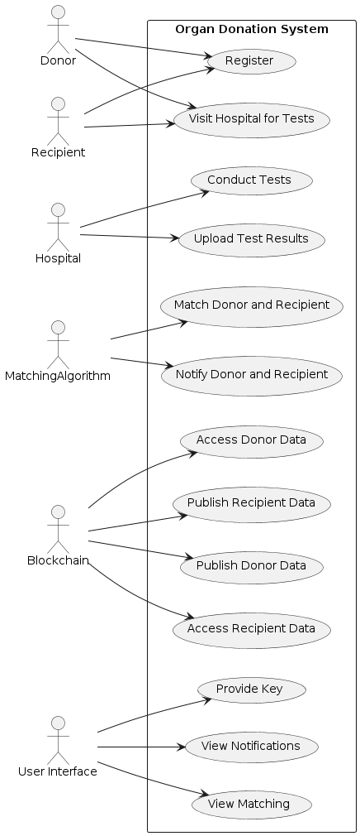

Figure 3.1 Use Case Diagram

## Data Flow Diagram

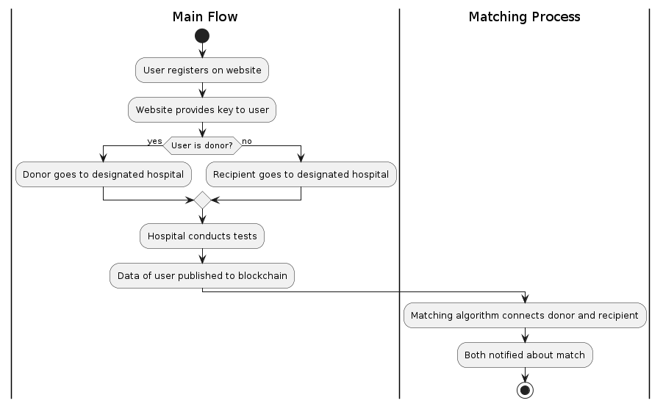

Figure 3.2 Data Flow Diagram

## Sequence Diagram

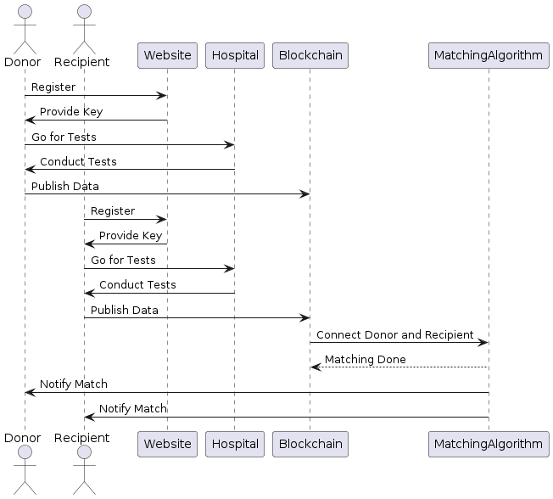

Figure 3.3 Sequence Diagram

## Class Diagram

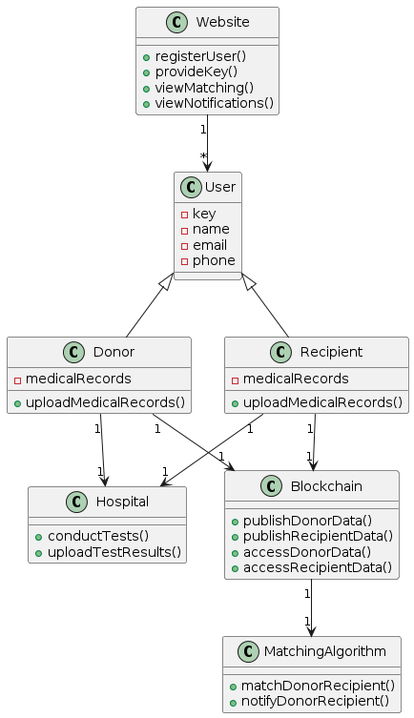

Figure 3.4 Class Diagram

## Gantt Chart

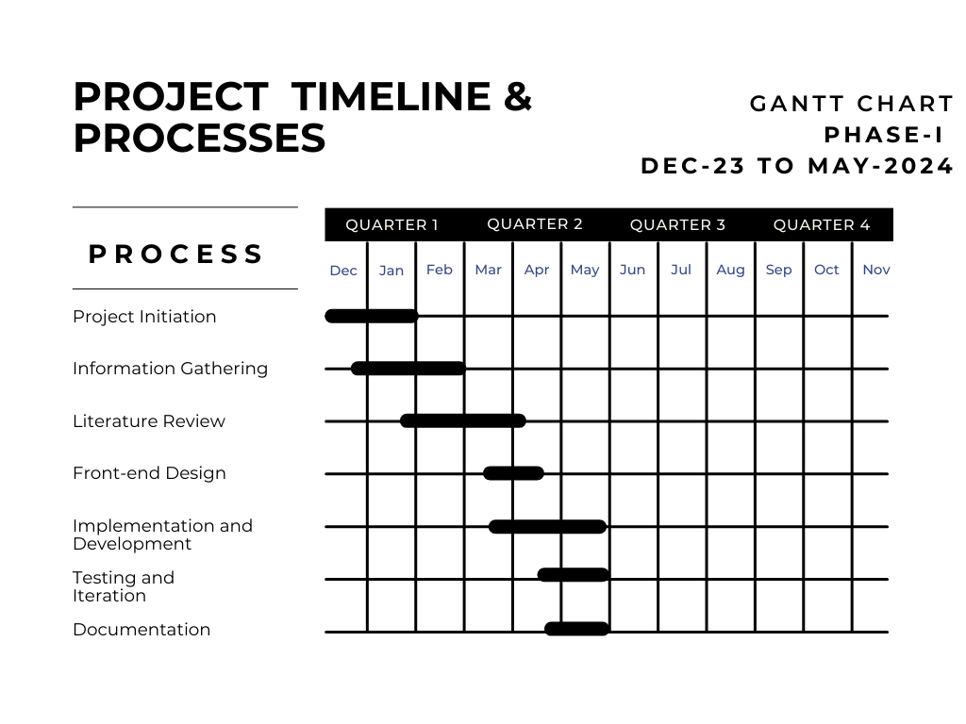

Figure 3.5 Gantt chart Project Timeline

# REFERENCES

1. Satyajit , Ghosha and Duttaa, Mousumi . Indriya: Building a Secure and Transparent Organ Donation System with Hyperledger Fabric. 2023.

2. ChatGPT. History and Background of Organ Donations. 2023.

3. Anselmo, Alessandro, et al. *Implementation of Blockchain*  *Technology Could Increase Equity and Transparency in Organ Transplantation: A Narrative Review of an Emergent Tool.* Department of Surgical Science, , University of Rome “Tor Vergata”. Rome, Italy : Transplant International, 2023.

4. *Blood and Organ Donation using Blockchain*  *Technology.* Sonawale, Rajeshree , et al. Navi Mumbai, Maharashtra, India : International Journal of Advanced Research in Science, Communication and Technology (IJARSCT) International, 2023.

5. *AI in Healthcare. In Revolutionizing Business Practices Through AI and Data-Rich Environments.* Choudhary, R., Kaushik, A. and Igulu, K. T. s.l. : IGI Global, 2022.

6. *"What is AI?".* Morandín-Ahuermaa and Fabio. s.l. : International Journal of Research Publication and Reviews 3, 2022, Vol. 12, pp. 1947 - 1951.

7. *"The AI Definition and a Program Which Satisfies this Definition.".* Dimiter. and Dobrev. s.l. : Institute of Mathematics and Informatic., 2022.

8. *"Application of AI and Blockchain*  *in Healthcare Management - Donor Organ Transplant System.".* Morande, Swapnil and Marialuisa Marzullo. s.l. : Annals of Management and Organization Research, 2019, Vol. 1, pp. 25 - 38.

9. *A Use Case for Developing Meta Architectures with AI and Agent Based Simulation in the Kidney Transplant Complex System of Systems.* Threlkeld, R. , Ashiku , L. and Dagli, C. Lille, France : Annual System of Systems Engineering Conference (SoSe), 2023, Vol. 18th, pp. 1 - 6.

10. *Hel-MCNN: Hybrid Extreme Learning Modified Convolutional Neural Network for Allocating Suitable Donors for Patients with Minimized Waiting Time.* s.l. : Expert Systems with Applications, 2023.

11. *Perspective of a Pathologist on Benchmark Strategies for AI Development in Organ Transplantation.* Eccher, Albino , et al. 3, s.l. : THE HOME FOR SCIENCE AND ENGINEERING, 2023, Vol. 28, pp. 1 - 6.

12. *How Whole Slide Imaging and AI Can Improve Organ Transplants.* Leonardo, Aviles Ovalle, et al. s.l. : Transplantation, 2022.

13. *ML in medicine.* A., Rajkomar, J., Dean and I., Kohane. 14, s.l. : The New England Journal pf Medicine, 2019, Vol. 380.

14. Gazette., Harvard. *A transplant makes history.* 2022.

15. *FACTS AND MYTHS ABOUT ORGAN DONATION.* [Online Paper] s.l. : American Transplant Foundation, 2023.

16. Jain, Utsav. *Using Blockchain*  *Technology for The Organ Procurement and Transplant Network.* s.l. : Master's Theisis, 2019.

17. He, Mai , et al. *Use of Forensic DNA Testing to Trace Unethical Organ Procurement and Organ Trafficking Practices in Regions that Block Transparent Access to their Transplant Data.* s.l. : SSRN, 2020.

18. *Organ Donation DApp Using Blockchain*  *Technology.* Dajim, Lama Abdulwahab, et al. Khamis Mushait, Saudi Arabia : International Conference on Computer Applications & Information Security (ICCAIS), 2019, Vol. 2.

19. *Blockchain* *-Based Management for Organ Donation and Transplantation.* JAYARAMAN, RAJA, et al. s.l. : IEEE Access, 2022.

20. *Investigating Ieligibility of Potential Living Liver Donors for Transplantation: Experience from a Large Liver Transplant Center in Pakistan.* Al Khalid, Abdullah and et al. s.l. : Journal of Liver Transplantation, 2023, Vol. 11, pp. 100163 - 100163.

21. *Human organ trafficking and transplantation: a legal analysis of causes, challenges and implementation of existing laws in Pakistan.* R. Q. , Idrees and S., Manzoor. 2, s.l. : Pakistan Journal of Social Research, 2023, Vol. 5, pp. 115 - 122.

22. *Obstacles to deceased donor transplantation in Pakistan.* K. , Ullah, et al. 1, s.l. : BMJ Open Gastroenterology, 2023, Vol. 10.

23. *Barriers and enablers to joining the National Organ Donation Registry among patient population at a tertiary care hospital.* Durrani, T., et al. Peshawar, Pakistan : Cureus, 2023, Vol. 15.

24. Hawashin, Diana Jawad. *Blockchain* *-enabled Management for Healthcare Waste Reduction and Donations.* Abu Dhabi : Khalifa University, 2022.

25. *Blockchain*  *based auditable medical transaction scheme for organ transplant services.* Alandjani, Gasim. 2, s.l. : 3C Technologia, 2019, Vol. 31, pp. 41 - 63.

26. *The current and future role of AI in optimizing donor organ utilization and recipient outcomes in heart transplantation.* Carlson, S., et al. 4, s.l. : Heart, Vessels, and Transplantation, 2022, Vol. 6, pp. 195 - 195.

27. *A New Era in Transplantation: AI, Augmented Reality, Virtual Reality and Metaverse.* Çolak, M. Y. and Haberal, M. 9S, s.l. : Transplanatation, 2022, Vol. 106, pp. S499 - S499.

28. *Intelligent organ transplantation system using rank search algorithm to serve needy recipients.* Raj , Adithya Pothan , et al. s.l. : International Conference on Innovative Computing, Intelligent Communication and Smart Electrical Systems (ICSES). IEEE, 2022, Vol. 2022.

29. *ML methods in organ transplantation.* Guijo-Rubio, D., Gutiérrez, P. A. and Hervás-Martínez, C. 4, s.l. : Current Opinion in Organ Transplantation, 2020, Vol. 25, pp. 399 - 405.

30. *Decision algorithm for heuristic donor-recipient matching.* Namatēvs, I. and Aleksejeva, L. 1, Brno, Czech Republic : MENDEL — Soft Computing Journal, 2017, Vol. 23.

31. *Learning matching representations for individualized organ transplantation allocation.* Xu, C., et al. s.l. : arXiv: ML., 2021.

32. *Nonimmunologic donor-recipient pairing, HLA matching, and graft loss in deceased donor kidney transplantation.* inson, A., et al. 1, s.l. : Transplantation Direct, 2019, Vol. 5.

33. *ML in predicting graft failure following kidney transplantation: A systematic review of published predictive models.* Senanayake, S., et al. 103957, s.l. : International Journal of Medical Informatics, 2019, Vol. 130.

34. *Predicting long-term outcomes of kidney transplantation in the era of AI.* Badrouchi, S., et al. 21273, s.l. : Scientific Reports, 2023, Vol. 13.

35. *ML models in predicting graft survival in kidney transplantation: meta-analysis.* Ravindhran, B., et al. 2, s.l. : BJS Open, 2023, Vol. 7.

36. *Predicting kidney graft survival using ML methods: Prediction model development and feature significance analysis.* Naqvi, S. A. A., et al. 8, s.l. : Journal of Medical Internet Research, 2021, Vol. 23.

37. *A predictive model for kidney transplant graft survival using ML.* Pahl, E. S., et al. s.l. : International Conference on Computer Science and Information Technology (COMIT), Smart Innovation, Systems and Technologies (SIPO), Advances in Intelligent Systems and Computing (AISCA), ML and Its Optimization in Bioinformatics (MLIOB), Big, 2020. pp. 99 - 108. CSCP 2020.

38. *Crossroads in liver transplantation: Is AI the key to donor–recipient matching?* Calleja Lozano, R., Hervás Martínez, C. and Briceño Delgado, F. J. 12, s.l. : Medicina, 2022, Vol. 58.

39. *Utility of an AI-enabled electrocardiogram for risk assessment in liver transplant candidates.* Zaver, H. B., et al. April 6, 2023, Vol. 68, pp. 2379–2388.

40. *AI and human liver allocation: Potential benefits and ethical implications.* Mucenic, M., de Mello Brandão, A. B. and Marroni, C. A. 1, s.l. : AI in Gastroenterology, 2022, Vol. 3, pp. 21 - 27.

41. *Maximizing utility of nondirected living liver donor grafts using ML. Frontiers in Immunology.* Bambha, K., et al. June 29, 2023.

42. *Machine-learning algorithms for predicting results in liver transplantation: The problem of donor–recipient matching.* Briceño, J., Ayllón, M. D. and Ciria, R. 4, s.l. : Current Opinion in Organ Transplantation, 2020, Vol. 25, pp. 406 - 411.

43. *Liver Disease Prediction Using Ensemble Technique.* Tanuku , Sai Rohith , et al. s.l. : International Conference on Advanced Computing and Communication Systems (ICACCS), March 26, 2022, Vol. 1, pp. 1522 - 1525.

44. *Statistical methods versus ML techniques for donor-recipient matching in liver transplantation.* Guijo-Rubio, D., et al. s.l. : PLOS ONE, 2021.

45. *A novel deep learning model as a donor-recipient matching tool to predict survival after liver transplantation.* Börner, N., et al. 21, s.l. : Journal of Clinical Medicine, 2022, Vol. 11.

46. *New models for donor-recipient matching in lung transplantations.* Dueñas-Jurado, J. M., et al. s.l. : PLOS ONE, 2021.

47. *Fully interactive lungs auscultation with AI-enabled digital stethoscope.* Grzywalski, T., et al. [ed.] Springer. s.l. : AI in Medicine in Europe (AIME 2019), 2019, pp. 31 - 35.

48. *Multi-Organ Failure Prediction using ML Approach.* Madhan Kumar, G. S., et al. 3, s.l. : International Journal of Scientific Research in Science and Technology, 2023, Vol. 10, pp. 19 - 24.

49. *Varsini, Ms V. Raaga, Ms A. Abitha, Ms CV Aarthi, and Mr MK Kowshik. "Blockchain Powered–Transparency in Organ Donation and Transplantation."*

50. Tanchip, Chelsea, Mohammad Noaeen, Kamyar Kazari, and Zahra Shakeri. *"Predicting Donor Selection and Multi-Organ Transplantation within Organ Procurement Organizations Using Machine Learning."*